Name:___________________________________________ Block:_______ MS: **Exp. Functions** (WS 2)

1. The function *f*(*x*) = 5 – 3(2–*x*) is defined for *x* ≥ 0.

(a) (i) On the axes below sketch the graph of *f*(*x*) and show the behaviour of the curve as *x* increases.

(ii) Write down the coordinates of any intercepts with the axes.

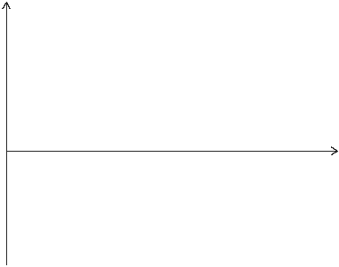

(4)

(b) Draw the line *y* = 5 on your sketch.

(1)

(c) Write down the number of solutions to the equation *f*(*x*) = 5.

(1)

(Total 6 marks)

2. A rumour spreads through a group of teenagers according to the exponential model

*N* = 2 × (1.81)0.7*t*

where *N* is the number of teenagers who have heard the rumour *t* hours after it is first started.

(a) Find the number of teenagers who started the rumour.

(2)

(b) Write down the number of teenagers who have heard the rumour five hours after it is first started.

(1)

(c) Determine the length of time it would take for 150 teenagers to have heard the rumour. **Give your answer correct to the nearest minute.**

(3)

(Total 6 marks)

3. The population of fleas on a dog after *t* days, is modelled by

*N* = 4 × , *t* ≥ 0,

Some values of *N* are shown in the table below.

|  |  |  |  |  |  |  |
| --- | --- | --- | --- | --- | --- | --- |
| *t* | 0 | 4 | 8 | 12 | 16 | 20 |
| *N* | *p* | 8 | 16 | 32 | *q* | 128 |

(a) Write down the value of

(i) *p*;

(ii) *q.*

(3)

(b) Using the values in the table above, draw the graph of *N* for 0 ≤ *t* ≤ 20. Use 1 cm to represent 2 days on the horizontal axis and 1 cm to represent 10 fleas on the vertical axis.

(6)

(c) **Use your graph** to estimate the number of days for the population of fleas to reach 55.

(2)

(Total 11 marks)

