I.B. Mathematical Studies Name: _______________________________________ Block: _________
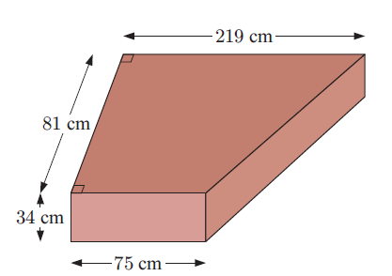
14 D Surface Area

