I.B. Mathematical Studies Name: _______________________________________ Block: _________
14 AB Conversions of Units and Perimeter
14A
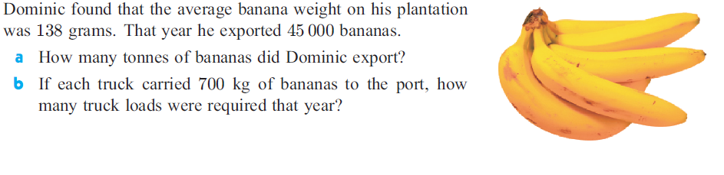

14B

