Name:___________________________________________ Block:__________ MS: Correlation

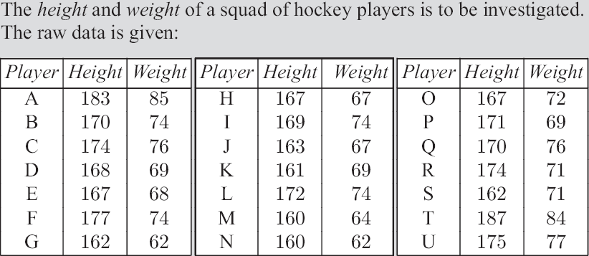
- State the independent variable.
- State the dependent variable.
- Calculate the mean weight.
- Calculate the mean height.
- Write down the mean-mean value.
- Create a scatter-plot with the given data. Be sure to label the x and y axis.
- Use the mean-mean value to create a line of best fit.
- Describe the correlation between the variables.

