In Class

2-Variable Statistics Lesson 2: Correlation Coefficient

Ex 1:

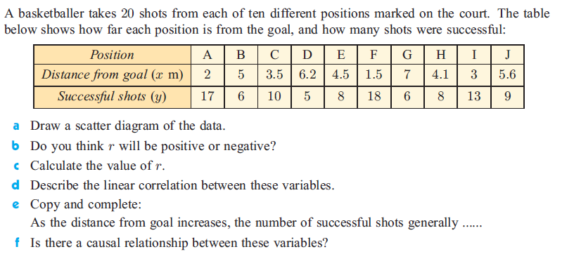

Ex 2:

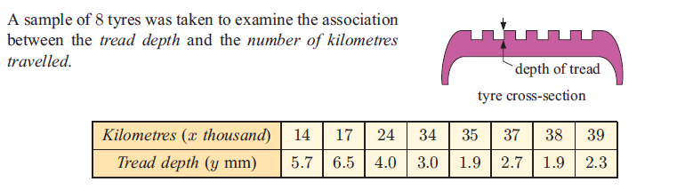

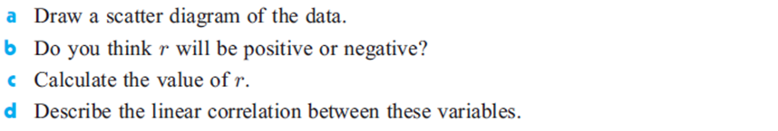

Ex 3.

The heat output in thermal units from burning 1 kg of wood changes according to the wood’s percentage moisture content. The moisture content and heat output of 10 blocks of the same type of wood each weighing 1 kg were measured. These are shown in the table.

|  |  |  |  |  |  |  |  |  |  |  |
| --- | --- | --- | --- | --- | --- | --- | --- | --- | --- | --- |
| **Moisture content % (*x*)** | 8 | 15 | 22 | 30 | 34 | 45 | 50 | 60 | 74 | 82 |
| **Heat output ( *y*)** | 80 | 77 | 74 | 69 | 68 | 61 | 61 | 55 | 50 | 45 |

(a) Draw a scatter diagram to show the above data. Use a scale of 2 cm to represent 10 % on the *x-*axis and a scale of 2 cm to represent 10 thermal units on the *y-*axis.

(4)

(b) Write down

(i) the mean percentage moisture content, ;

(ii) the mean heat output, *.*

(2)

(c) Plot the point ()on your scatter diagram and label this point M.

(2)

(d) Write down the product-moment correlation coefficient, *r.*

(2)

The equation of the regression line *y* on *x* is *y* = –0.470*x* + 83.7.

(e) Draw the regression line *y* on *x* on your scatter diagram.

(2)

(f) Estimate the heat output in thermal units of a 1 kg block of wood that has 25 % moisture content.

(2)

(g) State, with a reason, whether it is appropriate to use the regression line *y* on *x* to estimate the heat output in part (f).

(2)

(Total 16 marks)