I.B. Mathematical Studies Year 2
In Class
Exponential Functions Lesson 1: Exponential Basics
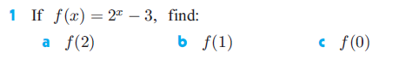

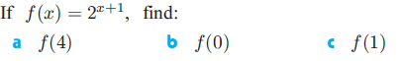

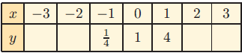
For the following please use the graph paper provided to draw the graph for the function.

- ________________________
- ________________________
- _____________
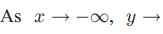
- _____________
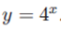
- Write an equation for the horizontal asymptote of

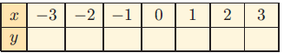
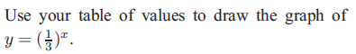

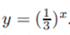
- Write an equation for the horizontal asymptote of

