Inside of Class
Normal Distribution Lesson 2: Inverse Normal Distribution

Ex. 1
The life of a Xenon battery has a normal distribution. The mean is 33.2 weeks and the standard deviation is 2.8 weeks. If a battery is selected at random,
- find the probability that it will last at least 35 weeks.
- Find the maximum number of weeks for which the manufacturer can expect that not more than 8% of batteries will fail.

Ex. 2
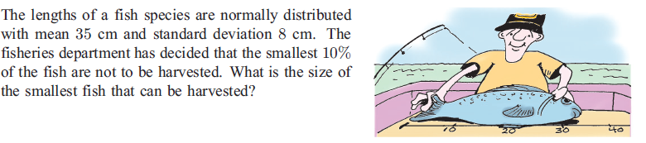

Ex. 3
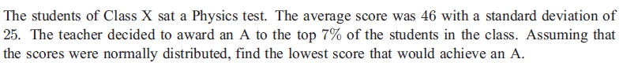

Ex. 4
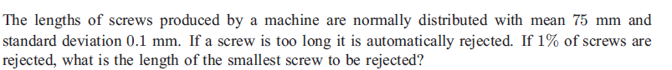

Ex. 5
