**In Class**

**Normal Distribution Lesson 1**

Ex. 1

1. Given that *X* is the time spent waiting in line at the Social Security Office that is normally distributed with a mean of 120 min and a standard deviation of 15min, find:
   1. 
   2. 
   3. 
   4. 
   5. 
   6. 
   7. 
   8. 
   9. 

Ex 2.

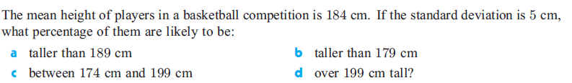

Ex 3.

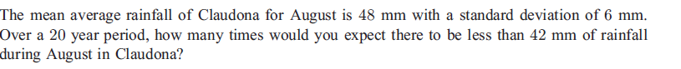

Ex 4.

