Outside of Class
Practice Probability Lesson 2: Theoretical Probability

Name:__________________________________________ Block:_______ MS: Theoretical Probability

1) A fair six-sided die has the numbers 1, 2, 3, 4, 5, 6 written on its faces. A fair four-sided die has the numbers 1, 2, 3, and 4 written on its faces. The two dice are rolled.
The following diagram shows the possible outcomes.
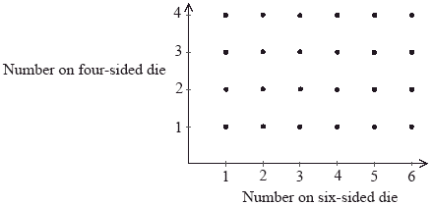
(a) Find the probability that the two dice show the same number.

(2)

(b) Find the probability that the difference between the two numbers shown on the dice is 1.

(2)

(c) Find the probability that the number shown on the four-sided die is greater than the number shown on the six-sided die, given that the difference between the two numbers is 1.
(2)
(Total 6 marks)

