OUTSIDE OF CLASS
Probability Lesson 3: Independent v. Dependent Probability
Ramzi travels to work each day, either by bus or by train. The probability that he travels by bus is 3/5. If he travels by bus, the probability that he buys a magazine is 2/3 . If he travels by train, the probability that he buys a magazine is ¾.
a. Complete the tree diagram
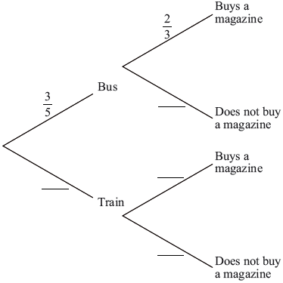

b. Find the probability that Ramzi buys a magazine when he travels to work.

