In Class

Probability Lesson 4: Non-Equally Likely Events

Explore:

Ex. 1

Two archers shoot at a target. Jim, the first archer, hits the target 3 out of 4 shots. Jill, the second archer, hits the target 4 out of 5 shots.

* Create a tree diagram with the above information.
* How many total outcomes are there?
* What is the probability both hit the target?
* What is the probability neither hits the target?
* What is the probability at least one archer hits the target?

Ex. 2

Maria travels to school either by walking or by bicycle. The probability she cycles to school is 0.75.

If she walks, the probability that she is late for school is 0.1.  
If she cycles, the probability that she is late for school is 0.05.

(a) Complete the tree diagram below, showing the appropriate probabilities.

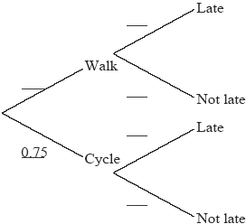

(b) Find the probability that Maria is late for school.

**Ex. 3**

A tin contains 7 chocolate biscuits and 3 plain biscuits. A child reaches into the tin and randomly selects 3 biscuits to be eaten.

1. Create a tree diagram below to represent the possible outcomes for this event.
2. What is the probability that ***at least*** one of the biscuits is chocolate?

**Ex. 4**

Amos travels to school either by car or by bicycle. The probability of being late for school is  if he travels by car and  if he travels by bicycle. On any particular day he is equally likely to travel by car or by bicycle.

(a) Draw a probability tree diagram to illustrate this information.

(b) Find the probability that

(i) Amos will travel by car and be late.

(ii) Amos will be late for school.