**Outside of Class**

Name:__________________________________________ Block:_______ MS: **Venn Diagrams**

1. A fitness club has 60 members. 35 of the members attend the club’s aerobics course (*A*) and 28 members attend the club’s yoga course (*Y*). 17 members attend both courses. A Venn diagram is used to illustrate this situation.

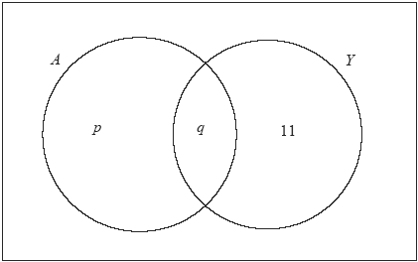

(a) Write down the value of *q*.

(1)

(b) Find the value of *p*.

(2)

(c) Calculate the number of members of the fitness club who attend neither the aerobics course (*A*) nor the yoga course (*Y*).

(2)

(d) Shade, on your Venn diagram, *A*′  *Y*.

(1)

(Total 6 marks)

clarinet.

(3)

(Total 14 marks)

4. The Venn diagram below shows the number of students studying Science (*S*), Mathematics (*M*) and History (*H*) out of a group of 20 college students. Some of the students do not study any of these subjects, 8 study Science, 10 study Mathematics and 9 study History.



(a) (i) How many students belong to the region labelled *A*?

(ii) Describe in words the region labelled *A*.

(iii) How many students do not study any of the three subjects?

(5)

(b) In the Venn diagram above, shade the region which represents *S*   *H*.

(1)

(c) Calculate *n*(*S*  *H*).

(2)

This group of students is to compete in an annual quiz evening which tests knowledge of Mathematics, Science and History. The names of the twenty students are written on pieces of paper and then put into a bag.

(d) One name is randomly selected from the bag. Calculate the probability that the student selected studies

(i) all three subjects;

(ii) History or Science.

(2)

(e) A team of two students is to be randomly selected to compete in the quiz evening. The first student selected will be the captain of the team. Calculate the probability that

(i) the captain studies all three subjects and the other team member does not study any of the three subjects;

(ii) one student studies Science only and the other student studies History only;

(iii) the second student selected studies History, given that the captain studies History and Mathematics.

(5)

(Total 15 marks)