Outside of Class

Probability Lesson 6: Conditional Probability Practice

Sharon and Lisa share a flat. Sharon cooks dinner three nights out of ten.
If Sharon does not cook dinner, then Lisa does. If Sharon cooks dinner the probability that they have pasta is 0.75. If Lisa cooks dinner the probability that they have pasta is 0.12.
(a) Complete the tree diagram to represent this information.
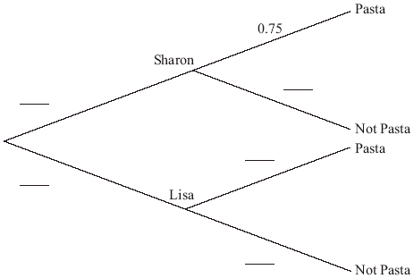
(3)
(b) Find the probability that Lisa cooks dinner and they do not have pasta.
(2)
(c) Find the probability that they do not have pasta.
(3)
(d) Given that they do not have pasta, find the probability that Lisa cooked dinner.
(3)
(Total 11 marks)

