In Class
Statistics Lesson 5: Grouped Continuous Data
Explore 1
The cumulative frequency graph shows the amount of time in minutes, 200 students spend waiting for their train on a particular morning.
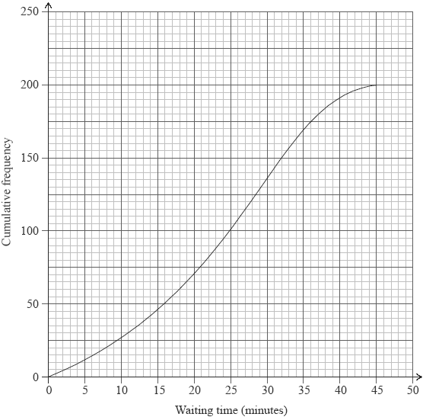
(a) Write down the median waiting time.
(b) Find the interquartile range for the waiting time.

Explore 2
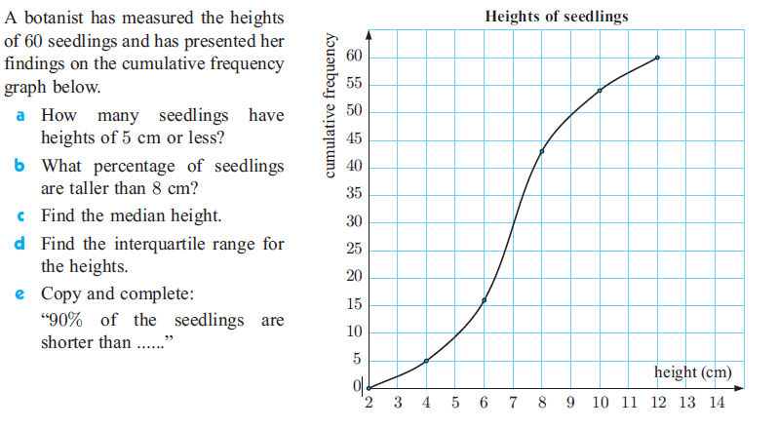

Explore 3.
