Outside of Class
Name:__________________________________________ Block:_______
Statistics Lesson 5: Grouped Continuous Data

- The diagram shows the cumulative frequency graph for the time t taken to perform a certain task by 2000 men.
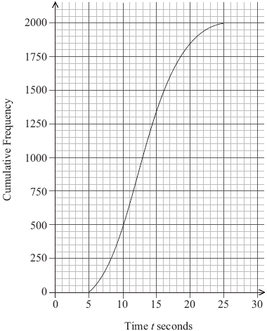
(a) Use the diagram to estimate
(i) the median time;

(ii) the upper quartile and the lower quartile;

(iii) the interquartile range.
(4)
(b) Find the number of men who take more than 11 seconds to perform the task.
(3)
(c) 55 % of the men took less than p seconds to perform the task. Find p.
(2)
The times taken for the 2000 men were grouped as shown in the table below.

Time | Frequency
5 ≤ t < 10 | 500
10 ≤ t < 15 | 850
15 ≤ t < 20 | a
20 ≤ t < 25 | b

(d) Write down the value of
(i) a;
(ii) b.
(2)
(e) Use your graphic display calculator to find an estimate of the mean time.
(2)

