Outside of Class

Statistics Lesson 4: Mead, Median, and Mode (Part 2)
- 120 Mathematics students in a school sat an examination. Their scores (given as a percentage) were summarized on a cumulative frequency diagram. This diagram is given below.
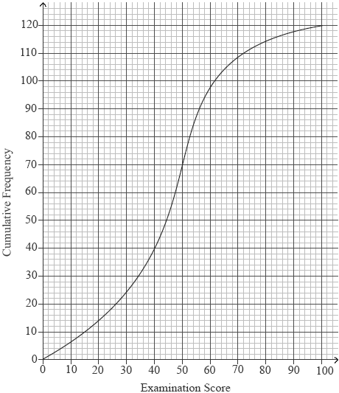
(a) Complete the grouped frequency table for the students.

Examination  Score x (%) | 0 ≤ x ≤ 20 | 20 < x ≤ 40 | 40 < x ≤ 60 | 60 < x ≤ 80 | 80 < x ≤ 100
Frequency | 14 | 26
(3)
(b) Write down the mid-interval value of the 40 < x ≤ 60 interval.
(1)
(c) Calculate an estimate of the mean examination score of the students.
(2)
(Total 6 marks)

