In Class
Statistics Lesson 7: Standard Deviation and Variance
Explore:
Ex. 1
Given the following data
Score | Frequency
11  12  13  14  15  16  17  18  19 | 3  4  5  2  8  9  5  8  6

- Find the standard deviation.
- Find the variance.

Ex. 2
The times taken for 2000 men to complete a task were grouped as shown in the table below.

Time | Frequency
5 ≤ t < 10 | 500
10 ≤ t < 15 | 850
15 ≤ t < 20 | 500
20 ≤ t < 25 | 150
(a) Use your graphic display calculator to find an estimate of
(i) the mean time;
(ii) the standard deviation of the time.

Everyone who performs the task in less than one standard deviation below the mean will receive a bonus. Pedro takes 9.5 seconds to perform the task.
(b) Does Pedro receive the bonus? Justify your answer.

Ex. 3
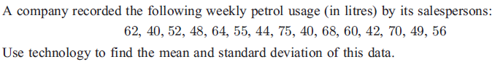

Ex. 4
